1.1 The Reason for Producing a Management Plan
Colne Local Nature Reserve has had a management plan for its component sites in one form or other since the 1990s and it has been revised periodically to remain current. In 2001 a long version plan for the site was formally adopted by the Borough Council and led to designation of the site as a Local Nature Reserve (LNR). This plan has now been reviewed and updated to accommodate the council’s priorities and to address the changes that have occurred on-site.

1.2 The Purpose of the Plan
Colne Local Nature Reserve forms part of Colchester’s LNR network. There are now seven LNRs in Colchester and three additional sites are due to be designated in the future. Therefore it is important to ensure that the site is managed so that it complies with the criteria that Natural England set out as being necessary and definitive for such designation.

The plan will:
- Assist the council to look at the long-term management of the site by setting management priorities.
- Provide continuity by providing a stable plan when personnel change (staff, management and councillors retire or move on).
- Enable the council to identify significant projects that are presently beyond their financial resources so that additional capital and revenue funding can be sought, possibly from outside organisations.
- Provide sound aims with which to approach other organisations and council departments with a view to working together to achieve mutual objectives.
- Allow staff to prepare annual work plans to manage the site in the medium term.
- Enable the council and local user groups to agree ongoing maintenance work to be carried out the council and volunteers.
- Inform all interested user groups and individuals about the long-term future of Colne LNR and explain to them the daily maintenance regime.

Other useful advantages include:
- Everyone - i.e. Colchester Borough Council, contractors, community groups, outside institutions - can work together to the same ends
- Provides open and 'transparent' decision making.
- It will help to address and hopefully resolve conflict created by different demands.
- Identify investment that needs to be made in the site.

1.3 The Life of The Plan
The plan is to inform policy making over the next 10 years. It contains a 5-year work plan (section 5.1) that will be reviewed annually as part of the process of creating an annual action plan. It will also make it more responsive to for example changes in wildlife populations. It is recommended that the whole plan be reviewed in 2018.

1.4 Vision and Aims
Colne LNR is a popular and well used open space, highly valued by local residents. It is also recognised as one of the most important urban fringe habitats in Colchester for wildlife.

1.4.1 The Vision for Colne LNR
The vision for Colne LNR is to enhance the use of the site for recreation by the local community while protecting its natural beauty, bio-diversity and landscape.

1.4.2 The Aims for Colne LNR

Overall Aim
1.4.2.1 To ensure that Colne LNR is maintained as a Local Nature Reserve, of benefit to both wildlife and people.

Site Aims
1.4.2.2 To conserve and where possible enhance the quality of woodland, grassland and wetland for the benefit of wildlife and species diversity.
1.4.2.3 To ensure that the Colne LNR landscape retains its strong landscape character and remains in good condition.

Community Aims
1.4.2.4 To provide suitable facilities and opportunities for public enjoyment of the site, for present and future generations of Colchesterians and visitors to the town, providing that these do not conflict with nature conservation requirements.
1.4.2.5 To provide opportunities for interpretation and encourage educational use.
1.4.2.6 To encourage community involvement in the site, and active involvement in the care and management of the site.
1.4.2.7 To ensure that Colne LNR is safe and accessible to all within the natural constraints of the site.
1.4.2.8 To ensure that anti-social behaviour is controlled and its impacts reduced.
1.4.2.9 To ensure that Colne LNR is well managed, and well resourced, balancing all the various public uses with the wildlife and heritage value of the site.

2.1 The Strategic Context
This section provides some strategic context within which the management plan has been produced and provides an example of how actions and aims within the management plan are both guided by, and relate back, to wider strategies.

2.1.1 The Strategic Plan 2012-15
The Council’s Strategic Plan sets out what, within available resources, Colchester Borough Council plan to achieve over the next three years towards the delivery of the longer-term vision for the borough. Colne LNR and other quality green spaces have an important role in contributing to the Strategic Plan priorities in the following ways:

- Lifelong learning – through engaging people both young and old in active learning, in ways which are creative and innovative.
- Healthy lifestyles – through providing and promoting opportunities for a wide range of informal outdoor recreational pursuits for people young and old.
- Creating a safer Colchester – through encouraging greater use of outdoor space and the development of an upward spiral of confidence.

2.1.2 Parks and Green Spaces Strategy (2008)
The Parks and Green Space Strategy (P&GSS) outlines a programme for the future provision of green space and the facilities and services that should be provided. Its core vision is to create a borough with good quality, attractive, enjoyable and accessible green spaces which meet the diverse needs of those who live, work and visit the town and its surroundings. The P&GSS can be viewed at: http://www.colchester.gov.uk/article/2748/Colchester-Parks-and-Green-Space-Strategy. Colne LNR contributes to the P&GSS priorities in the following ways;

- Through enabling community participation in the improvement and management of green spaces.
- Through encouraging greater use and enjoyment of Colchester’s green spaces by all sectors of the community.
- By protecting needed green space from development.
- By encouraging active and healthy life-styles.
- By protecting and enhancing biodiversity in green spaces.

3.1 Name of the Site
Colne Local Nature Reserve.

3.2 Location and Area
Grid reference: TM 035222 (approximate centre of site)
Area: 28.9 hectares (71.4 acres)
Location: See Fig 1. Colne Local Nature Reserve (outlined in yellow) and Upper Colne Marshes Site of Special Scientific Interest (in yellow)

Fig 1. 3.3 Ownership, tenure and access
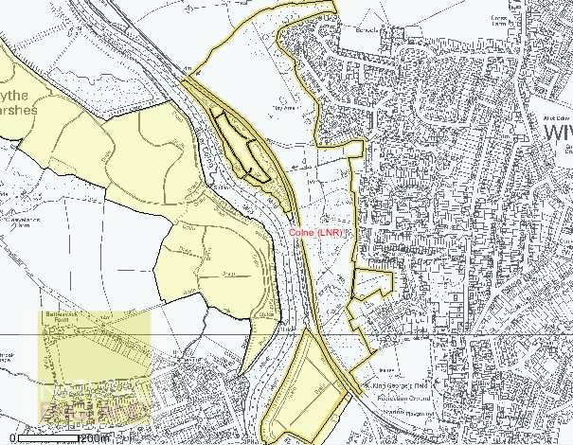
The Colne LNR is owned freehold by the council and managed by its Parks and Recreation
department (Countryside). It comprises Wivenhoe Wood, Ferry Marsh and Lower Lodge Farm.

3.3.1 Wivenhoe Wood
Whilst no public rights of way exist in the Wivenhoe Wood itself there are many well established paths running through the site. A right of way does run along the flood defence wall but is not used. The Wivenhoe Trail (a cycle route established by the council in the 1980s) runs through the north western corner and is used in lieu of the right of way.
3.3.2 Ferry Marsh
- A small area of marsh to the south west belongs to Wivenhoe Quay Limited. An additional area (formerly used for dredgings), to the west, is also owned by the company.
- The Countryside and Rights of Way Act (2000) places on public bodies, including local authorities, a duty to further the conservation and enhancement of Sites of Special Scientific Interest (SSSIs) in their care.
- The Environment Agency’s current policy for flood defence is to maintain the seawall to the west of the site to its current protective standard in the foreseeable future. New capital works will be considered by applying strict cost-benefit criteria, and where a line of defence is economically viable the defence will be sustained. The Agency are responsible for drainage structures in the wall.
- There is open public access throughout the marsh though, in practice, this is limited by the wet nature of the site. A public right of way runs along the river’s flood defence wall.

3.3.3 Lower Lodge Farm Open Space
Two public rights of way lie within the main body of the site and connect with the Wivenhoe Trail to the west via a crossing point over the railway line and University-owned land to the north. Another right of way lies on the western boundary and follows the flood defence wall but, in practice, people walk the Wivenhoe Trail rather than this route.

In addition to the public rights of way there is a network of footpaths across the whole site some of which are maintained and some are "desire lines" which are are extensively used for dog walking and other recreational activities.

3.4 Designations
- Local Nature Reserve (LNR)
- Site of Special Scientific Interest - Wivenhoe Ferry Marsh is part of the Upper Colne Marshes Site of Special Scientific Interest
- Local Wildlife Site Ref CO154 – applies to Wivenhoe Wood only (Date of original selection: 1991 Date of last revision: December 2008)
- Public Rights of Way (PROW)

3.5 Wildlife

3.5.1 Wivenhoe Wood Local Wildlife Site (Fig. 2)
According to the Local Wildlife Site citation “the northern half of the Wivenhoe Wood is ancient wood, but the remainder is secondary cover. The original canopy cover of the southern section comprises Pedunculate Oak (Quercus robur) and Ash (Fraxinus excelsior) but is now co-dominated by Silver Birch (Betula pendula) and Sycamore (Acer pseudoplatanus) following the great storm of 1987, which opened up the canopy to these invasive species. The ancient section includes a good deal of Sweet Chestnut (Castanea sativa), some of which has been recently coppiced.The ground flora is variable and under pressure from localised heavy trampling and play pressure, although it is recognised that this wood has an important role to play in the countryside experience of local residents (Urban HAP significance). The ground cover in the modern secondary wood is dominated by Ivy (Hedera helix), but overall the flora is diverse, with Wood Sedge (Carex sylvatica), Scaly Male Fern (Dryopteris affinis), Bluebell (Hyacinthoides non- scripta), Hairy Wood-rush (Luzula pilosa) and Hart’s-tongue Fern (Phyllitis scolopendrium) indicating the ancient status of parts of the site.” The key Biodiversity Action Plan priority habitats are Lowland Mixed Deciduous Woodland (UK); Ancient Woodland, Urban Habitats (Essex).
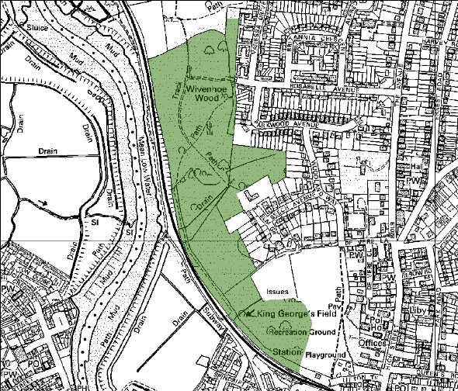

Fig. 2

3.5.2 Wivenhoe Ferry Marsh (Fig. 3)
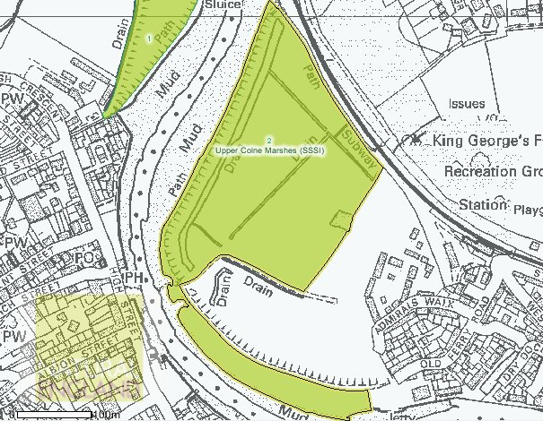
Wivenhoe Ferry Marsh supports a range of habitats, which include several of national conservation value: coastal grazing marsh; brackish water ditch system with associated marsh and swamp habitats; small areas of transitional woodland; areas of scrub and sea wall. The species list is incomplete but includes ca. 150 plants, 20 species of bird and 84 species of aquatic invertebrates.
Birds – the 2000 breeding bird survey (Larkin) recorded 20 species of which 14 species held a total of 25 territories. The most numerous species is reed warbler (seven territories). Two UKBAP priority species were recorded; reed bunting and linnet, though there was evidence of the latter breeding. Barn Owl probably hunts over the marsh (C. Gibson, English Nature pers. com.). There is no information on wintering birds.
Fig. 3
Water Voles – Water vole are well established and numerous. Their habitat was extended in 2010.
Invertebrates – compared with other Essex grazing marsh sites, Wivenhoe Ferry Marsh has a good, but not outstanding range of acquatic invertebrate species. A total of 84 species were recorded during the 2001 survey (Wilson P. and Wilson P.). All were frequently found during the Essex grazing marshes survey (Drake, 1986) except microvelia pygmaea, helophorus griseus and anacaena bipustulata.

The key Biodiversity Action Plan priority habitats are coastal grazing marsh (Essex) and saline lagoons (UK).

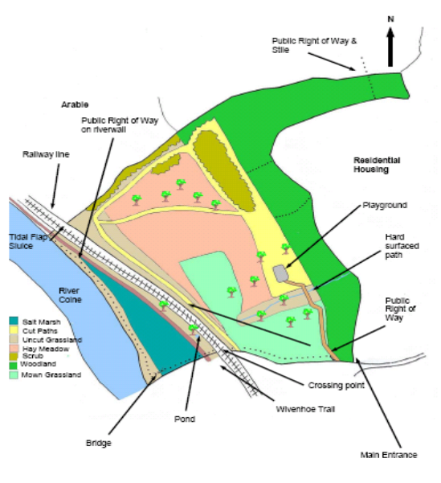
3.5.3 Lower Lodge Farm Open Space (Fig. 4)

Lower Lodge supports semi-natural grassland, secondary woodland, and a range of fresh and brackish water habitats. The summer hay meadow, cut annually on a rotation, is attractive and comprises species rich in nectar such as knapweed , field scabious, trefoils, vetches and fine grasses on the upper slope. Within there are areas of scattered and dense scrub which, together with the boundary hedges, provide sheltered and warm conditions for common lizard introduced in 2003 from a nearby development site, and odonata and orthoptera. The dense scrub holds locally significant numbers of blackcap, chiffchaff and whitethroat territories (Larkin). Woodland to the east was planted during the 1980s in association with the adjacent housing. Species are mixed, mainly native broadleaved, and rather uniform in their layout. There is no shrub layer and the ground flora is dominated to ivy, bramble and common ruderals.

Fig. 4

The main seepage line within the site lies within a corridor of coppiced willows, great hairy willowherb, flote-grass and fool’s watercress. The small pond situated in scrub between the Wivenhoe Trail and railway line supports reedmace and sea-club rush (). Ditches on the northern and southern boundaries support salt marsh flora including sea aster and sea couch. Oaks and their seedlings are also abundant. Nearby are other seasonally damp areas. Nearer to the river and part of the SSSI is an area of primary tidal salt marsh small area of intertidal mud. The salt marsh supports common saltmarsh-grass, sea aster and common sea-lavender () whilst the old sea wall comprises improved grassland with a natural scrub community of blackthorn

3.6. Local Nature Reserves (LNRs)
Colchester Borough Council officially declared the Colne LNR in 2002, under the 1949 National Parks and Access to the Countryside Act. The site was one of several LNRs declared at that time, all of which were selected with the guidance and approval of English Nature (now Natural England). These sites were selected on the basis of their high nature conservation value, and the fact that each site supported a contrasting range of habitats and species. The importance of public enjoyment of nature and education were also crucial factors in the declaration of the LNRs. The cultural and historical importance of the Colne LNR was highlighted at the time of the site’s declaration as an LNR. The P&GSS outlines the council’s aim to continue the programme of designating LNRs in order to meet Natural England’s recommended national standard.

4.1 Recent Management Operations (2002 – 12)

Wivenhoe Wood
4.1.1 Since 2002 an area of ancient woodland at the heart of Wivenhoe Wood has been successfully coppiced (Fig. 5) . The original aim was to create 0.5 ha coupes cut on a 10 year rotation though it now appears more likely a 12 year rotation will be achieved. In 2005 – 6 areas of coppice were successfully gap planted mostly with thorn. Some of the larger stools next to the railway line have been left and checked for safety.
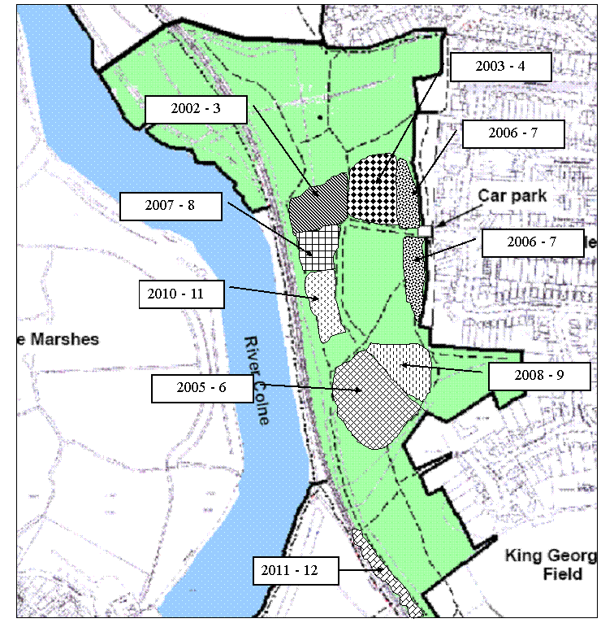
During the same period, sycamore (beyond the area of ancient woodland) was controlled by cutting and the use of herbicide. Stumps and regrowth were also treated with herbicide. In addition and within the area of ancient woodland – towards its southern boundary - large single stemmed sycamores were felled and treated, and self-seeded sycamores removed by pulling. Clearings created by the removal of sycamore were replanted successfully with hazel, hawthorn and oak.

The secondary woodland to the south and east has had limited intervention except for the cutting and treating of sycamore. Some path work was carried out to improve drainage and a long length of boardwalk installed in 2008 across the muddy path next to the railway line. The central valley was ‘opened up’ by the removal of shrubs, and subsequently maintained. An area of dense shrubs nearby was coppiced each year to retain optimum habitat for nightingale.

Fig. 5

Sycamore north of the coppice area was cut and treated in the winter between 2006 – 9 with trees planted to fill in the gaps in 2007 – 8. Secondary woodland to the north of the woods has not been coppiced.

Some ride widening was carried out during the 2002 – 3. This was not completed in the anticipated way, partly due to local opposition at the time but also because of the positive effects of coppicing in the vicinity of the path. The ride widening that was done in 2002 – 3 was re-coppiced in 2005 – 6 and 2008 – 9. No ride widening was carried out in the secondary woodland.

Walks and activities were organised by the countryside ranger, as well as by external groups. The Colchester Natural History Society led walks as well as moth lamping on Ferry Marsh and in Wivenhoe Woods. In Easter 2007 Neil Jones, a local author carried out a series of writing workshops in the woods. Broomgrove Primary School use the wood for Forest School sessions; a collaboration with the council and Essex Wildlife Trust.

The Wivenhoe Working Party - local community volunteers - assist the countryside ranger look after the site. The Rosabelle Avenue car park was surfaced though the approach road to the car park remains potholed and in need of repair. Physical access throughout the site has been significantly improved with repairs to the disabled access, replacement of all four bridges within the woods (one by local scouts as part of their Duke of Edinburgh Award) and a wooden boardwalk installed on the path next to the railway line. In addition new benches and picnic benches were installed. New interpretation panels – based on the old ones - were erected and there is now a display cabinet in the car park.

Wivenhoe Ferry Marsh
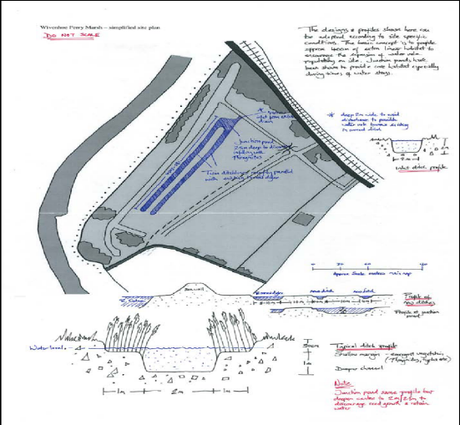
    - Since 2002 management has concentrated on improving the condition of the SSSI unit in
collaboration with Natural England, Environment Agency and Essex Wildlife Trust’s Water for Wildlife Officer. The current condition as assessed by Natural England is currently ‘unfavourable recovering’ (last assessed by C. Williams 18/11/10).

However, no grazing or grass cutting has been possible – except for maintenance of the sites main public path - due to the prolonged disputes over access land with Wivenhoe Quay Ltd, and extensive and long-lasting flooding that occurred some years back. The latter was resolved by the Environment Agency.

Fig. 6
New water vole ditches (Fig. 6) were created in October 2010 and have proved successful (see report
T:\Parks & Rec\SUBJECT\COUNTRYSIDE SITES\Countryside - OPERATIONAL\Colne LNR - Ferry Marsh\Surveys & related\Water vole habitat creation 2010.pdf). Since this date some of the older ditches were mechanically slobbed out and riparian vegetation hand pulled to maintain open water.

Ongoing faunal surveys have been carried out by the Water for Wildlife Officer and Colchester Natural History Society.
To enhance other wildlife habitats and ensure public access a programme of scrub and tree clearance has been carried out adjacent to the footpath and ditches. Additional public access improvements include the installation of a welcome sign at the main entrance and bridges over the ditches and maintenance of the river wall path. Unfortunately the Section 106 Agreement ‘viewing area’ by the Bovis-built housing has not materialised.

Lower Lodge Farm Open Space
4.1.3 Since 2002 one third of the meadow has been cut and cleared each year in sections demarcated by existing footpaths. The arisings were composted on site rather than removed. Two sections to the north are managed as lizard refugia with the areas demarcated by a planted belt of trees (mostly Hazel and Hawthorn). In addition some brash has been left for basking. Two hibernacula were built in 2008 and 2009. The lizard population appears to be relatively stable; annual monitoring by EECOS ended some years ago. The amenity grassland has been maintained through regular cutting as specified in the council’s grounds maintenance contract.

The seepage line has been maintained by coppicing on a rotation as were the trees adjacent to the pond west of the railway line. Oaks along the seepage line have been removed. The pond itself is maintained by occasional clearance. Planted willow was removed and stumps treated in 2003.

Spring Lane is kept clear by cutting of overhanging vegetation and the surface is maintained by the occasional addition of road planings. Public access is maintained by mowing paths and has been assisted by the installation of a boardwalk over the seepage line. A hard surface path was laid in 2003, and the grass edge has been maintained by spraying with a glyphosate based herbicide. To assist visitors a ‘Lower Lodge Farm’ welcome board is situated to the play area and contact plates in place.

5.1 Management Operations

Wivenhoe Wood
5.1.2 Sycamore
- Continue to control as described in 4.1.1; the approach has been relatively successful. Although saplings are pulled following the coppicing many still survive.
- Remove and treat single stemmed sycamore from coppice areas after coppicing.

5.1.3 Coppicing
- Use the coppicing contract with Essex Arboricultural Ltd to carry out the programme of coppicing and selective felling, in line with the Forestry Commission Felling License and its replanting conditions. Link to Felling License T:\Parks & Rec\SUBJECT\COUNTRYSIDE SITES\Countryside - OPERATIONAL\Colne LNR - Wivenhoe Wood\Felling License\Felling License 2013 - 16.pdf
- Fell the large coppice stools adjacent to the railway line as required by Network Rail.
- Review the number of standards in the coupes and fell a limited number.
- Carry out a Tree Risk Assessment for the whole wood and implement the tree safety work on a planned programme.
- Update the coppicing map showing dates of work.
- Compile and map the future coppice rotation (approximately 10 years)

5.1.4 Secondary woodland and shrubs
- Carry on the pattern of work established in previous years to achieve a diverse structure with trees and shrubs of uneven age and heights.
- Leave some of the secondary woodland to the north of the wood as non-intervention with the remainder coppiced.

5.1.5 Improving the central ride
- Select and treat some of the stools along the central ride edge once coppiced so as to prevent re-growth and allow light penetration.

5.1.6 Interpretation, education and promotion
- Maintain the current level of interpretation and panels.
- Promote the sites facilities and our services to local schools.
- Promote management works and news to the local community.
- Work with local groups such as the Wivenhoe Forum and Wivenhoe TC in respect of wildlife events and information.

5.1.7 Community participation, public access and enjoyment
- Patrol/inspect the site fortnightly.
- Repair the approach to the car park if it can be done without accepting any liability for future maintenance (it is not owned by the Council).
- Continue to maintain the existing structures, paths and countryside furniture.
- Continue to support and develop the Wivenhoe Working Party holding practical tasks particularly between October and March each year.
- Publicise and lead an annual management meeting for the whole LNR with local people producing and distributing an action plan afterwards.
- Litter pick whilst patrolling especially in the picnic area and car park.

Wivenhoe Ferry Marsh
5.1.8 Control and enhance the grassland
- Coppice areas of blackthorn to prevent it from spreading further into the site (including the larger sections of blackthorn and not just the patches next to the ditches).
- Remove and treat selected trees encroaching into the grassland and reedbeds.
- Seek ways to enhance the grassland through cutting.
- Ensure the grounds maintenance work is carried out in timely and effective fashion by the contractor.
- Check, maintain, re-strain and replace the boundary and internal fences/gates as required.

5.1.9 Control and enhance the ditch system
- Remove and treat (with glyphosate where appropriate) trees and shrubs encroaching on the ditches to prevent over shading and loss of riparian vegetation. Follow up by strimming any re-growth 3 – 5m from the ditches.
- Strim re-growth from stumps within 5m of the dyke edge to prevent it re-establishing. Stumps beyond the 5m will be allowed to re-grow.
- Continue to improve the water vole habitat through a planned programme of ditch maintenance and enhancement work as supported and authorised by Natural England and the local Water for Wildlife Officer.
- Clear riparian vegetation/slob out ditches as required and spread material away from ditches.

5.1.10 Monitor notable species
- Permit/arrange monitoring of notable species and maintain records for the site.

5.1.11 Improving public access, interpretation and understanding
- Patrol/inspect the site fortnightly.
- Provide and install small interpretation and visitor information panels at the sites entrances.
- Ensure new visitor information is uploaded to the Council’s web page for the whole LNR.
- Publicise management works by means of temporary notices.

Lower Lodge Farm Open Space
    - Enhance the grassland and lizard refugia
- Continue to maintain the moderately species-rich semi-improved grassland by rotational cutting, clearing and composting of the sward on-site. In 2013 concentrate on the areas that support oak seedlings and saplings.
- Control undesirable species such as creeping thistle and common ragwort so their cover is less than 1% of the area.
- Encourage taller grass tussocks and allow small areas of bare ground for the lizards.
- Maintain the lizard refugia in an optimal state i.e. tussocks, scattered scrub cover and hibernacula. Prune or coppice the demarcation line of planted trees. Seek advice of CNHS or other specialists if required.
- Pull/brush cut the oak saplings/seedlings near to large oak trees – missed by hay cut – on a rotational basis to prevent further establishment.
- Continue to coppice trees within the seepage line as required.

5.1.13 Enhance the woodland
- Create a woodland buffer zone behind the properties of the adjacent housing estate in line with the Felling License. Undertake the works by offering it to Essex Arboricultural Ltd as an additional item on their contract or by arranging for another contractor to do it after agreeing a price and timescale. The Felling License requires that the buffer zone be coppiced and restocked (if necessary) so it will be necessary to decide on a rotation for re-coppicing.
- Ensure that the Tree Risk Assessment for Wivenhoe Wood includes the woodland at Lower Lodge.

5.1.15 Enhance the pond
- Dredge 1/3 of pond next to the railway line and clear over shading woody vegetation on a cyclical basis.

5.1.16 Interpretation, education and promotion
- Patrol/inspect the site fortnightly.
- Proactively work with local schools to promote the site as a Forest Schools venue in line with the Services protocol and charges.
- Liaise with and inform local residents in respect of trees works to the woodland buffer zone. Erect temporary notices.
- Renew dog waste notice(s).
- Work with Essex Police in respect of the main ‘Venny’ event in May each year.

5.1.17 Access
- Maintain and replace as required countryside furniture.
- Review boardwalk and consider extending it.
- Maintain edges of surfaced path between Spring Lane and play area.

6.1 Financial and Health & Safety considerations

6.1.1 Most of the costs associated with carrying out the planned maintenance and regular tasks at Wivenhoe Wood and Lower Lodge Farm open space will be met from existing Parks and Recreation revenue budgets. Some of these works are incorporated into, and the costs met from, the grounds maintenance contract. Works to maintain and/or enhance the lizard receptor site at Lower Lodge will continue to be met from a dedicated S106 Agreement contribution. It is expected that major planned tree works will be done within the terms of the no-cost Coppicing Contract 2013-16. The woodland behind Dixon Way etc. which requires remedial work to deal with repeated insurance claims for subsidence and heave will – if agreed with the contractor – be added to this contract. The annual budget for works at Ferry Marsh will - for the duration of this management plan – be met from on a S106 Agreement contribution associated with the nearby housing development. One-off projects e.g. visitor information panels will probably require funding from external sources in the form of grant-aid.

6.1.2 It is anticipated that the Countryside Ranger responsible for the Colne LNR will lead the management operations listed above deploying contractors and volunteers, and working with internal and external colleagues, as required. The priorities and precise timing of operations will be agreed each year between the ranger and Countryside Sites Manager through the action plan process following a site meeting in late summer organised by the ranger. Invitees will include representatives from the Town Council and/or Wivenhoe Society as well as local users.

6.1.3 The service’s Safety Handbook will provide the health and safety standards and arrangements that will apply to employees, contractors and volunteers carrying out operations on the Colne LNR.

Appendix 1 Wivenhoe Wood species list

Flowering Plants
Acer campestre field maple
Acer pseudoplatanus sycamore
Achillea millefolium yarrow
Adoxa moschatellina moschatel
Aesculus hippocastanum horse chestnut
Ajuga reptans bugle
Alliaria petiolata garlic mustard
Alnus glutinosa alder
Anemone nemorosa wood anemone
Anthriscus sylvestris cow parsley
Apium nodiflorum fool’s watercress
Artemisia vulgaris mugwort
Artemisia maritima sea wormwood
Arctium minus lesser burdock
Arum maculatum cuckoo pint
Aster tripolium sea aster
Ballota nigra black horehound
Bellis perennis daisy
Betula pendula silver birch
Betula pubescens downy birch
Bryonia dioica white bryony
Callitriche agg water starwort
Capsella bursa-pastoris shepherd’s purse
Cardamine flexuosa wavy bittercress
Cardamine hirsuta hairy bittercress
Carpinus betulus hornbeam
Castanea sativa sweet chestnut
Centaurea nigra knapweed
Cerastium fontanum common mouse-ear
Cerastium glomeratum sticky mouse-ear

Chamerion angustifolium rosebay willowherb
Circaea lutetiana enchanter’s nightshade
Cirsium arvense creeping thistle
Cirsium vulgare spear thistle
Conopodium majus pignut
Convolvulus arvensis field bindweed
Conyza canadensis canadian fleabane
Cornus sanguinea dogwood
Corylus avellana hazel
Crataegue monogyna common hawthorn
Crepsis vesicaria beaked hawksbeard
Cytisus scoparius broom
Digitalis purpurea foxglove
Dryopteris dilatata broad buckler fern
Dryopteris filix-mas male fern
Duchesnea indica yellow-flowered strawberry
Epilobium ciliatum american willowherb
Epilobium hirsutum great hairy willowherb
Epilobium montanum broad-leaved willowherb
Equisetum arvense field horsetail
Erodium cicutarium common storksbill
Euonymus europaeus spindle
Euphorbia amygdaloides wood spurge
Fallopia convolvulus black bindweed
Fragaria vesca wild strawberry
Fraxinus excelsior ash
Fumaria capreolata white ramping fumitory
Galeopsis tetrahit common hemp nettle
Galium aparine goosegrass
Geranium dissectum cut-leaved cranesbill
Geranium robertianum herb robert
Geranium molle dovesfoot cranesbill
Geum urbanum wood avens
Glechoma hederacea ground ivy
Hedera helix ivy
Heracleum sphondylium hogweed
Humulus lupulus hop
Hyacinthoides non-scripta bluebell
Hypericum androsaemum tutsan
Hypericum perforatum common st john’s wort
Hypochaeris radicata catsear
Ilex aquifolium holly
Lamiastrum galeobdolon yellow archangel
Lamium album white dead nettle
Lamium purpureum red dead nettle
Lapsana communis nipplewort
Larix decidua european larch
Leontodon autumnalis autumn hawkbit
Leycesteria formosa himalayan honeysuckle
Linaria vulgaris common toadflax
Listera ovata common twayblade
Lonicera periclymenum honeysuckle
Lotus corniculatus common birdsfoot trefoil
Lysimachia nemorum yellow pimpernel
Malva sylvestris common mallow
Matricaria discoidea pineapple weed
Mercurialis perennis dog’s mercury
Medicago arabica spotted medick
Medicago lupulina black medick
Moehringia trinervia three-nerved sandwort
Ornithopus perpusillus birdsfoot
Oxalis acetosella wood sorrel
Pastinaca sativa wild parsnip
Pentaglottis sempervirens green alkenet
Picris sylvestris bristly ox-tongue
Pinus sylvestris scots pine
Plantago lanceolata ribwort plantain
Plantage major greater plantain
Plantage maritima sea plantain
Polygonum aviculare knotgrass
Polystichum setiferum soft shield fern
Populus tremula aspen
Potentilla argentea hoary cinquefoil
Potentilla reptans creeping cinquefoil
Potentilla sterilis barren strawberry
Prunus avium wild cherry
Prunus spinosa blackthorn
Pteridium aquilinum bracken
Quercus cerris turkey oak
Quercus ilex holm oak
Quercus robur pedunculate oak
Ranunculus bulbosus bulbous buttercup
Ranunculus ficaria lesser celandine
Ranunculus flammula lesser spearwort
Ranunculus repens creeping buttercup
Ribes rubrum red currant
Rosa arvensis field rose
Rosa canina dog rose
Rosa rugosa japanese rose
Rubus fruticosus bramble
Rubus idaeus raspberry
Rumex acetosa common sorrel
Rumex acetosella sheep’s sorrel
Rumex crispus curled dock
Rumex obtusifolius broad-leaved dock
Salix caprea goat willow
Salix cinerea grey willow
Salix fragilis crack willow
Salix purpurea purple willow
Salix viminalis osier
Sambucus nigra elder
Scrophularia nodosa common figwort
Scutellaria galericulata common skullcap
Senecio jacobaea ragwort
Senecio sylvaticus heath groundsel
Senecio vulgaris groundsel
Silene alba white campion
Silene dioica red campion
Sisymbrium officinale hedge mustard
Solanum dulcamara woody nightshade
Sonchus asper prickly sow-thistle
Sonchus oleraceus smooth sow-thistle
Sorbus aucuparia rowan
Stachys sylvatica hedge woundwort
Stellaria holostea greater stitchwort
Stellaria media common chickweed
Tamus communis black bryony
Taraxacum agg dandelion
Taxus baccata yew
Teucrium scorodonia wood sage
Tragopogon pratensis goatsbeard
Trifolium dubium lesser yellow trefoil
Trifolium pratense red clover
Trifolium repens white clover
Tussilago farfara coltsfoot
Ulex europaeus gorse
Ulmus agg elm
Ulmus glabra wych elm
Urtica dioica stinging nettle
Veronica arvensis wall speedwell
Veronica chamaedrys germander speedwell
Veronica hererifolia ivy-leaved speedwell
Veronica montana wood speedwell
Veronica serpyllifolia thyme-leaved speedwell
Viburnum opulus geulder rose
Vicia hirsuta hairy tare
Vicia sativa common vetch
Viola riviniana common dog violet

Grasses, Rushes and Sedges
Agrostis capillaris common bent
Agrostis stolonifera creeping bent
Aira praecox early hair-grass
Alopecurus pratensis meadow foxtail
Anthoxanthum odoratum sweet vernal grass
Arrhenatherum elatius false oat-grass
Brachypodium sylvaticum false brome
Bromus hordeaceus soft brome
Bromus sterilis barren brome
Carex divulsa grey sedge
Carex remota remote sedge
Carex sylvatica wood sedge
Cynosurus cristatus crested dogstail
Dactylis glomerata cocksfoot
Descampsia cespitosa tufted hair-grass
Elymus pycnanthus sea couch
Elytrigia repens common couch
Holcus lanatus yorkshire fog
Holcus mollis creeping soft grass
Isolepis setacea bristle clubrush
Juncus bufonius toad rush
Juncus effusus soft rush
Lolium perenne perennial rye-grass
Luzula campestris field woodrush
Luzula pilosa hairy woodrush
Milium effusum wood millet
Poa annua annual meadow-grass
Poa nemoralis wood meadow-grass
Poa pratensis smooth meadow-grass
Poa trivialis rough meadow-grass
Phragmites australis common reed
Puccinellia maritima common saltmarsh-grass
Scirpus maritimus sea club-rush
Triglochin maritima sea arrow-grass
Typha latifolia greater bulrush
Vulpia bromoides squirrel-tail fescue

Birds (status based on Common Bird Census 2000)

Song Thrush
Small numbers present throughout the year; singing males present in scrubby valley. No evidence of breeding.

Mistle Thrush
A breeding resident in the wood, 2-3 pairs.
Turtle Dove
A likely breeding resident in the scrubby valley; 3 singing males in April.
Bullfinch
Recorded in small numbers in wood.
Nightingale
Common summer visitor and passage migrant. No signs of breeding success but 7 singing males around scrubby valley and railway line.
Dunnock
Common breeding resident with territories spread throughout the site.
Starling
Common throughout the year.
Blackbird
Common breeding resident; minimum of 21 territories.
Robin
Common breeding resident; approximately 25 territories.
Wren
Common breeding resident; 27 singing males recorded throughout though absent from old coppice area.
Chaffinch
Common resident with 10 territories and confirmed breeding success.
Great Tit
Common breeding resident; 15 territories identified.
Blue Tit
Common breeding resident; 14 territories.
Willow Warbler
Summer visitor; 2 territories in scrubby valley.
Blackcap
Common summer visitor (3-8 pairs); in coppice and scrubby valley.
Chiffchaff
Common summer visitor and passage migrant; 10 singing males although no breeding proven. Found in dense stands of scrub.
Garden Warbler
Summer visitor and passage migrant; 2 singing males in scrubby valley though no breeding proved.
Whitethroat
Common summer visitor; 8-9 territories in low dense scrub. No proven breeding.
Great Spotted Woodpecker
Likely resident throughout the year; 3 territories with one in Town Council woodland. Successful breeding on at least one pair.
Tawny Owl
Two males calling from the wood though no evidence of nest sites or breeding.
Greenfinch
Three singing males on boundary of site with Lower Lodge Farm open space; juveniles recorded.
Woodpigeon
Common breeding resident
Jay
Recorded in small numbers.
Magpie
Common throughout the year.
Crow
Common throughout the year.
Cuckoo
Summer visitor; 2-3 males calling.
Pheasant
Numerous males present.
Red legged partridge
Occasional; recorded from high salt marsh.

Appendix 2 Lower Lodge Farm Open Space species list

Flowering Plants
Acer campestre field maple
Achillea millefolium yarrow
Aesculus hippocastanum horse chestnut
Ajuga reptans bugle
Alliaria petiolata garlic mustard
Alnus glutinosa alder
Anemone nemorosa wood anemone
Anthriscus sylvestris cow parsley
Apium nodiflorum fool’s watercress
Artemisia maritima sea wormwood
Arctium minus lesser burdock
Arum maculatum cuckoo pint
Aster tripolium sea aster
Bellis perennis daisy
Betula pubescens downy birch
Bryonia dioica white bryony
Capsella bursa-pastoris shepherd’s purse
Carpinus betulus hornbeam
Castanea sativa sweet chestnut
Centaurea nigra knapweed
Cerastium fontanum common mouse-ear
Cerastium glomeratum sticky mouse-ear
Circaea lutetiana enchanter’s nightshade
Cirsium arvense creeping thistle
Cirsium vulgare spear thistle
Conopodium majus pignut
Convolvulus arvensis field bindweed
Cornus sanguinea dogwood
Corylus avellana hazel
Crataegue monogyna common hawthorn
Cytisus scoparius broom

Duchesnea indica yellow-flowered strawberry
Epilobium ciliatum american willowherb
Epilobium hirsutum great hairy willowherb
Epilobium montanum broad-leaved willowherb
Equisetum arvense field horsetail
Erodium cicutarium common stork’s-bill
Euonymus europaeus spindle
Fallopia convolvulus black bindweed
Fraxinus excelsior ash
Galium aparine goosegrass
Geranium dissectum cut-leaved cranesbill
Glechoma hederacea ground ivy
Hedera helix ivy
Heracleum sphondylium hogweed
Humulus lupulus hop
Hyacinthoides non-scripta bluebell
Hypericum perforatum common st john’s wort
Hypochaeris radicata catsear
Ilex aquifolium holly
Lamium album white dead nettle
Lonicera periclymenum honeysuckle
Lotus corniculatus common birdsfoot trefoil
Malva sylvestris common mallow
Pinus sylvestris scots pine
Plantago coronopus buck’s horn-plantain
Plantago lanceolata ribwort plantain
Plantage major greater plantain
Plantage maritima sea plantain
Populus tremula aspen
Prunus avium wild cherry
Prunus spinosa blackthorn
Pteridium aquilinum bracken
Quercus robur pedunculate oak
Ranunculus bulbosus bulbous buttercup
Ranunculus ficaria lesser celandine
Ranunculus flammula lesser spearwort
Ranunculus bulbosus bulbous buttercup
Ranunculus ficaria lesser celandine
Ranunculus repens creeping buttercup
Rosa arvensis field rose
Rosa canina dog rose
Rosa rugosa japanese rose
Rubus fruticosus bramble
Rumex acetosa common sorrel
Rumex acetosella sheep’s sorrel
Rumex crispus curled dock
Rumex obtusifolius broad-leaved dock
Salix caprea goat willow
Salix viminalis osier
Sambucus nigra elder
Senecio jacobaea ragwort
Silene alba white campion
Silene dioica red campion
Solanum dulcamara woody nightshade
Sonchus asper prickly sow-thistle
Sonchus oleraceus smooth sow-thistle
Stachys sylvatica hedge woundwort
Stellaria holostea greater stitchwort
Stellaria media common chickweed
Taraxacum agg dandelion
Taxus baccata yew
Tragopogon pratensis goatsbeard
Trifolium dubium lesser yellow trefoil
Trifolium pratense red clover
Trifolium repens white clover
Ulex europaeus gorse
Urtica dioica stinging nettle
Veronica chamaedrys germander speedwell
Veronica hererifolia ivy-leaved speedwell
Veronica serpyllifolia thyme-leaved speedwell
Vicia hirsuta hairy tare
Vicia sativa common vetch
Viola riviniana common dog violet

Grasses, Rushes and Sedges
Alopecurus pratensis meadow foxtail
Dactylis glomerata cocksfoot
Elymus pycnanthus sea couch
Holcus lanatus yorkshire fog
Juncus effusus soft rush
Lolium perenne perennial rye-grass
Luzula campestris field woodrush
Poa annua annual meadow-grass
Poa pratensis smooth meadow-grass
Poa trivialis rough meadow-grass
Phragmites australis common reed
Puccinellia maritima common saltmarsh-grass
Scirpus maritimus sea club-rush
Triglochin maritima sea arrow-grass
Typha latifolia greater bulrush

Appendix 3 Wivenhoe Ferry Marsh species list

Flowering plants
Achillea millefolium Yarrow
Agrostis stolonifera Creeping bent
Alliaria petoilata Garlic mustard
Alopecurus geniculatus Marsh foxtail
Alopecurus pratensis Meadow foxtail
Anthriscus sylvestris Cow parsley
Armeria maritima Thrift
Armoracia rusticana Horse radish
Arrhenatherum elatius False oat-grass
Artemisia absinthium Wormwood
Artemisia vulgaris Mugwort
Arum maculatum Lords and Ladies
Aster tripolium Sea aster
Atriplex littoralis Grass-leaved orache
Atriplex portulacoides Sea purslane
Atriplex prostrata Spear-leaved orache
Beta vulgaris ssp. Maritima Sea beet
Betula pendula Silver birch
Bolbschoenus maritimus Sea clubrush
Brassica nigra Black mustard
Bromus hordeaceus ssp. hordeaceus Soft brome
Callitriche stagnalis Water starwort
Cardamine hirsuta Hairy bittercress
Carex divisa Divided sedge
Carex otrubae False fox sedge
Castanea sativa Sweet chestnut
Cerastium fontanum Common mouse-ear
Cerastium glomeratum Sticky mouse-ear
Ceratophyllum demersum Rigid horwort
Chamerion angustifolium Rosebay willowherb
Cirsium arvense Creeping thistle

Cirsium vulgare Spear thistle
Cochlearia anglica English scurvy grass
Conium maculatum Hemlock
Crataegus monogyna Common hawthorn
Crepis vesicaria ssp taraxacifolia Beaked hawksbeard
Cynosurus cristatus Crested dogstail
Dactylis glomerata Cocksfoot
Dipsacus fullonum Wild teasel
Elytrigia atherica var atherica Sea couch
Elytrigia repens var repens Common couch
Enteromorpha spp. Sea grass
Epilobium hirsutum Great willowherb
Epilobium parviflorum Hoary willowherb
Erophila verna Comon whitlowgrass
Euphorbia peplus Petty spurge
Festuca arundinacea Tall fescue
Festuca rubra agg Red fescue
Festuca ovina Sheep's fescue
Fraxinus excelsior Ash
Galium aparine Cleavers
Geranium dissectum Cut-leaved cranesbill
Geum urbanum Wood avens
Hedera helix Ivy
Holcus lanatus Yorkshire fog
Hypochaeris radicata Catsear
Ilex aquifolium Holly
Juncus bufonius sl Toad rush
Juncus conglomeratus Compact rush
Juncus effusus Soft rush
Juncus geradi Saltmarsh rush
Juncus maritimus Sea rush
Lactuca serriola f integrifolia Prickly lettuce
Lactuca virosa Great lettuce
Lamium purpureum Red dead nettle
Lapsana communis Nipplewort
Lathyrus nissolia Grass vetching
Lemna minor Common duckweed
Lemna trisuica Ivy duckweed
Lepidium draba ssp. draba Hoary cress
Lepidium latifolium Dittander
Limonium vulgare Common sea lavender
Lolium perenne Perennial rye-grass
Lotus corniculatus Common birdsfoot trefoil
Lotus glaber Narrow leaved birdsfoot trefoil
Lycopus europaeus Gipsywort
Medicago arabica Spotted medick
Medicago lupulina Black medick
Myriophyllum spicatum Spiked water milfoil
Papaver somniferum Opium poppy
Phleum bertolonii Small catstail
Phragmites australis Common reed
Picris echioides Bristly ox-tongue
Plantago coronopus Buckshorn plantain
Plantago lanceolata Ribwort plantain
Plantago major ssp. major Greater plantain
Plantago maritimus Sea plantain
Poa annua Annual meadow-grass
Poa pratensis Smooth meadow-grass
Poa trivialis Rough meadow-grass
Polygonum aviculare Knotgrass
Potamogeton pectinatus Fennel pondweed
Potentilla anserina Silverweed
Potentilla sterilis Barren strawberry
Prunus avium Wild cherry
Prunus spinosa Blackthorn
Puccinellia maritima Common saltmarsh-grass
Quercus ilex Holm oak
Quercus robur Pedunculate oak
Rununculus acris Meadow buttercup
Rununculus baudotii Brackish water crowfoot
Rununculus bulbosus Bulbous buttercup
Rununculus repens Creeping buttercup
Rununculus sardous Hairy buttercup
Rununculus sceleratus Celery-leaved buttercup
Rosa canina Dog rose
Rubus fructicosus Bramble
Rumex acetosella Sheep's sorrel
Rumex conglomeratus Clustered dock
Rumex crispus Curled dock
Ruppia maritima Beaked tasselweed
Salix cinerea agg Grey willow
Sambucus nigra Elder
Senecio erucifolius Hoary ragwort
Senecio jacobaea Common ragwort
Senecio squalidus Oxford ragwort
Senecio sylvaticus Heath groundsel
Senecio vulgaris Groundsel
Sisymbrium officinale Hedge mustard
Solanum dulcamara Woody nightshade
Sonchus arvensis Perennial sow-thistle
Sonchus asper Prickly sow-thistle
Sonchus oleraceus Smooth sow-thistle
Spartina anglica Common cord-grass
Spergularia media Greater sea spurrey
Stachys sylvatica Hedge woundwort
Stellaria holostea Greater stitchwort
Stellaria media Common chickweed
Suaeda maritima Common seablite
Taraxacum agg Dandelion
Torilis japonica Upright hedge parsley
Tragopogon pratensis Goatsbeard
Triglochin maritima Sea arrow-grass
Trifollium dubium Lesser trefoil
Trifolium pratense Red clover
Trifolium repens White clover
Trifolium striatum Knotted clover
Trsetum flavescens Yellow oat-grass
Typha angustifolia Lesser bulrush
Typha latifolia Greater bulrush
Ulmus agg Elm
Urtica dioica Common nettle
Vicia cracca Tufted vetch
Vicia hirsuta Hairy tare
Vicia sativa Common vetch
Vicia tetrasperma Smooth tare
Vulpia bromoides Squirrel-tail fescue
Vulpia myuros Ratstail fescue
Zannichellia palustris Horned pondweed

Birds
Acrocephalus schoenobaenus Sedge warbler
Acrocephalus scirpaceus Reed warbler
Carduelis cannabina Linnet
Carduelis carduelis Goldfinch
Dendrocopos major Great spotted woodpecker
Emberiza schoeniclus Reed bunting
Erithacus rubecula Robin
Fringilla coelebs Chaffinch
Gallinula chloropus Moorhen
Parus caeruleus Blue tit
Parus major Great tit
Phasianus colchicus Pheasant
Phylloscopus collybita Chiffchaff
Sturnus vulgaris Starling
Sylvia atricapilla Blackcap
Sylvia borin Garden warbler
Sylvia communis Whitethroat
Troglodytes troglodytes Wren
Turdus merula Blackbird

Aquatic invertebrates
Mollusca
Potamopyrgus jenkinsi Jenkins spire snail

Crustacea
Asellus aquaticus Water hog louse
Asellus meridianus
Cladocera ‘Daphnia’ group
Copepoda
Gammarus duebeni
Gammaru zaddachi
Neomysis integer
Palaemonetes varians Prawn

Sphaeroma hookeri

Ephemeroptera Mayflies
Cloeon dipterum

Odonata Damsel and Dragonflies
Ischnura elegans nymph Blue tailed damselfly
Sympetrum striolatum nymph Common Darter
Damselfly, early instar
Aeshna cyanea nymph Southern Hawker
Aeshna grandis (flying) Brown Hawker
Aeshna mixta nymph Migrant Hawker

Hemiptera Heteroptera Water Bugs
Callicorixa praeusta Water boatman
Corixa panzeri Water boatman
Gerris odontogaster Pond skater
Gerris thoracicus Pond skater
Gerris sp. juveniles
Hesperocorixa linnaei Water boatman
Hesperocorixa sahlbergi Water boatman
Hydrometra stagnorum Water measurer
Microvelia pygmacea
Microvelia reticulata
Nepa cinerea Water scorpion
Notonecta glauca Back swimmer
Notonecta viridis Back swimmer
Sigara concinna Water boatman
Sigara dorsalis Water boatman
Sigara falleni Water boatman
Sigara stagnalis Water boatman

Tricoptera Caddisflies
Empty case

Coleoptera Beetles
Agabus bipustilatus
Agabus conspersus
Agabus nebulosus
Agabus sturmii
Anacaena bipustilata
Anacaena limbata
Anacaena lutescens
Coelambus parallelogrammus
Colymbetes fuscus
Copelatus haemorrhoidalis
Cymbiodyta marginella
Dytiscus larva (very large)
Dytiscus semisulcatus A Diving beetle
Enochrus halophilus
Enochrus testaceus
Gyrinus caspius Whirligig beetle
Haliplus lineatocollis
Haliplus ruficollis
Haliplus sp. females
Helophorus aequalis
Helophorus griseus
Helophorus minutus
Helophorus sp. females
Hydrobius fuscipes
Hydroporus memnonius
Hydroporus palustris
Hydroporus planus
Hygrotis inaequalis
Hyphydrus ovatus
Ilybius ater
Laccobius bipunctatus
Limnoxenus niger
Noterus clavicornis
Ochthebius minimus
Rhantus frontalis
Scirtes sp. larva

Diptera True flies
Anopheles maculipennis larva Mosquito
Ceratopogonidae larva Biting midges
Chironomus sp. larva Blood worms
Other Chironomid larvae
Culicine mosquito larvae
Tipulid larvae Crane flies
Dixella (autumnalis) Meniscus midge
Dixella sp. indet
Oplodontha viridula larvae A soldier fly

Hydrocarinids indet Water mite

Bryozoa Moss animals
Plumatella reptans

Fish
Gasterosteus aculeatus 3-spine stickleback
Pungitius pungitius 10 spine stickback

